Interval Notation

An interval is a length of time or space that has a defined start and end point.

All of these ranges have a defined start and a defined end. Sometimes that start or end is represented by a point, which means the graph is limited at that numerical value (x- or y-value). Other times, the start or end is represented by an arrow, which means the graph is limited by eternity, which, mathematically, is either positive or negative infinity ($-∞ on the left or$
$bottom \&+∞ on the right or top)$.

Before we can work on these intervals, we have to understand and be able to properly notate them.
Rules for Changing Inequalities to Interval Notation:  - $<or>$ (no line under) is written using $( or )$  & $≤or≥$ (line under) is written using $[ or ]$  - Any value on the “less” or closed side of the inequality  $$here< >here here≤ or ≥here$$  is the lower limit and is written on the left side of the interval.  - Any value on the “greater” or open side of the inequality  $$here> <here here≥ or ≤here$$  is the upper limit and is written on the right side of the interval.  - If there is not a number in the lower limit position, only in the upper limit ($x<number)$, then the left side of the interval is always $"(-∞,"$.  - If there is not a number in the upper limit position, only in the upper limit ($x>number)$, then the right side of the interval is always $"∞)"$. | EXAMPLE 1: Write $x≥4$ in interval notation.  *$x≥4$ has 4 on the closed side, which makes it a lower limit, so it goes on the left side (rule 2).  $$4, ?$$  *The symbol $≥$ has a line under it, so the 4 will get a square bracket [ or ] (rule 1).  $$[4, ?$$  *There is not a number in the upper limit position, so the right side of the interval is $∞)$ (rule 5).  $$[4, ∞)$$  $x≥4$ can be written as: $\boxed{[4, ∞)}$  EXAMPLE 2: Write $-3<x≤5$ in interval notation.  *$-3<x$ has -3 on the closed side, making it a lower limit, which goes on the left side (rule 2), and the symbol $<$ does not have a line under it, so the -3 will get a parenthesis ( or ) (rule 1).  $$(-3,$$  *$x≤5$ has 5 on the open side, making it an upper limit, which goes on the right side (rule 3), and the symbol $≤$ has a line under it, so the 5 will get a square bracket [ or ] (rule 1).  $$\boxed{(-3, 5]}$$

Write each interval (currently expressed as inequalities) in interval notation.
EXAMPLE 3: $x<-2$  $<-2$ means -2 is on the right with ]  No other limit means the left is $(-∞$  $$\boxed{(-∞,-2]}$$ | 1. $-7≤y<-3$ | 2. $-2<x<3$
3. $x≥8$ | 4. $y<-3$ | 5. $-11≤x≤-9$
6. $x<1$ | 7.$y≥5$ | 8. $-4<x≤-3$

Intervals on a Quadratic Graph

There are four quadratic intervals that you need to be able to identify: Domain, Interval of Increase & Interval of Decrease, and Range. On a graph, intervals are parts of the coordinate plane that are used for certain things. Domain is the part of the coordinate plane from left to right (x-values) that a graph uses. The interval of increase is the part of the coordinate plane from left to right (x-values) that a graph uses while it is rising, and the interval of increase is the part of the coordinate plane from left to right (x-values) that a graph uses while it is falling.

Range is the only interval that we’re working on today that is about y-values. Range is the part of the coordinate plane from bottom to top (y-values) that a graph uses.

 | Domain uses x-values | Interval of Increase uses x-values | Interval of Decrease uses x-values
Parabolas that Face Down | 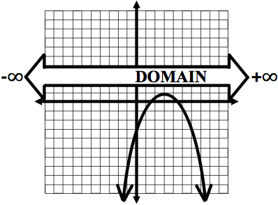  Inequality: $-∞<x<∞$  Interval Notation: $(-∞, ∞)$ | 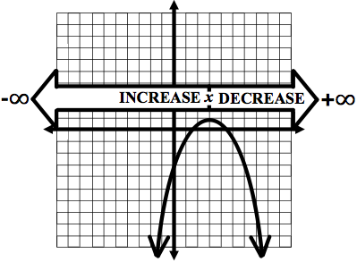  Increase is the left side of the quadratic, so our lower limit is $-∞$ & our upper limit is the axis of symmetry ($x=3$).  Inequality: $x<3$  Interval Notation: $(-∞, 3)$ | Decrease is the right side of the quadratic, so our lower limit is the axis of symmetry ($x=3$) & our upper limit is $+∞.$  Inequality: $x>3$  Interval Notation: $(3,∞)$
Parabolas that Face Up | 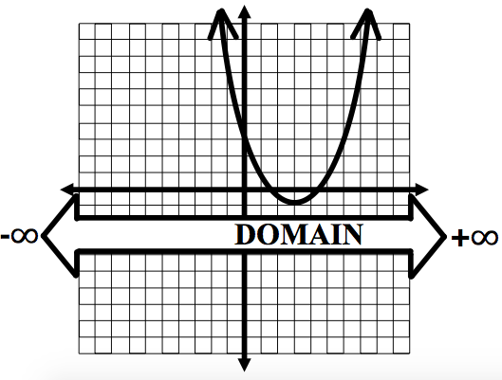  Inequality: $-∞<x<∞$  Interval Notation: $(-∞, ∞)$ | 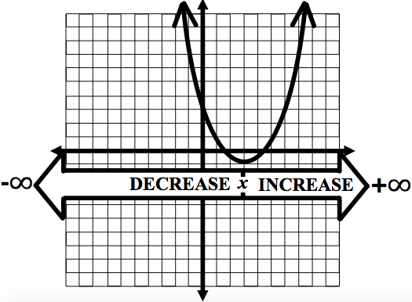  Increase is the right side of the quadratic, so our lower limit is the axis of symmetry ($x=3$) & our upper limit is $+∞.$  Inequality: $x>3$  Interval Notation: $(3,∞)$ | Decrease is the left side of the quadratic, so our lower limit is $-∞$ & our upper limit is the axis of symmetry ($x=3$).  Inequality: $x<3$  Interval Notation: $(-∞, 3)$

Range uses  y-values | 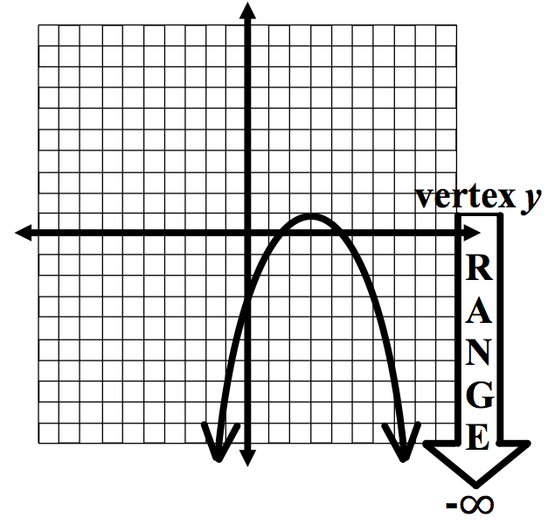  The vertex is the top of our parabola, so the lower limit is $-∞$& the upper limit (which is part of the graph) is the maximum ($y=1$).  Inequality: $y≤1$  Interval Notation: $(-∞, 1]$ | 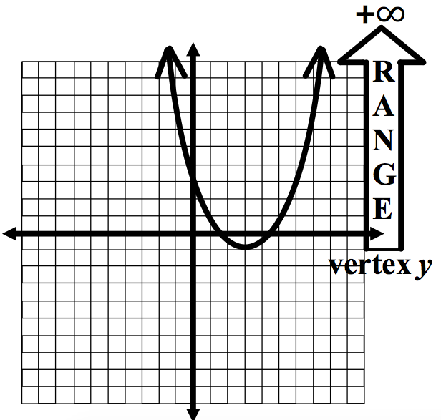  The vertex is the bottom of our parabola, so the lower limit (which is part of the graph) is the minimum ($y=-1$) & the upper limit is $+∞$.  Inequality: $y≥-1$  Interval Notation: $[-1, ∞)$

Determine the four intervals for each quadratic, as an inequality & as an interval.
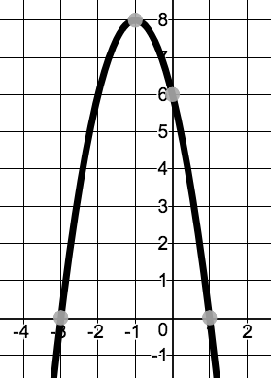  EXAMPLE: The graph faces down, so…  Domain:  $$-∞<x<∞$$  $$(-∞, ∞)$$  Increase: on left side & vertex x is -1  $$-∞<x<-1$$  $$(-∞, -1)$$  Decrease: on right side & vertex x is -1  $$-1<x<∞$$  $$(-1, ∞)$$  Range: Vertex y is a maximum at 8  $$y≤8$$  $$(-∞, 8]$$ | 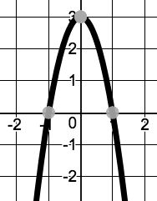  1.  Domain:  Increase:  Decrease:  Range:
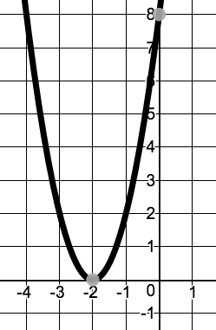  2.  Domain:  Increase:  Decrease:  Range: | 3.  Domain:  Increase:  Decrease:  Range:
4.  Domain:  Increase:  Decrease:  Range: | 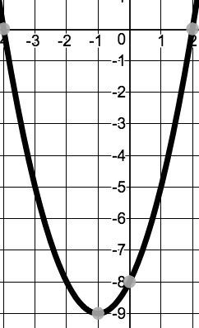  5.  Domain:  Increase:  Decrease:  Range:

Interval Notation Answers
1. $[-7, -3)$ | 2. $(-2, 3)$ | 3. $[8, ∞)$ | 4. $(-∞, 3)$
5. $[-11, -9]$ | 6. $(-∞, 1)$ | 7. $[5, ∞)$ | 8. $(-4, -3]$

Intervals on a Quadratic Graph Answers
1. D: $-∞<x<∞$, $(-∞, ∞)$  II: $-∞<x<0$, $(-∞, 0)$  ID: $0<x<∞$, $(0, ∞)$  R: $y≤3$, $(-∞, 3]$ | 2. D: $-∞<x<∞$, $(-∞, ∞)$  II: $-2<x<∞$, $(-2, ∞)$  ID: $-∞<x<-2$, $(-∞, -2)$  R: $y≥0$, $[0,-∞)$ |  | 3. D: $-∞<x<∞$, $(-∞, ∞)$  II: $-∞<x<-3$, $(-∞, -3)$  ID: $-3<x<∞$, $(-3, ∞)$  R: $y≤4$, $(-∞, 4]$
4. D: $-∞<x<∞$, $(-∞, ∞)$  II: $-∞<x<0$, $(-∞, 0)$  ID: $0<x<∞$, $(0, ∞)$  R: $y≤4$, $(-∞, 4]$ |  | 5. D: $-∞<x<∞$, $(-∞, ∞)$  II: $-1<x<∞$, $(-1, ∞)$  ID: $-∞<x<-1$, $(-∞, -1)$  R: $y≥-9$, $[-9,-∞)$
Domain, Intervals of Increase & Decrease and Range Information
Domain | Intervals of Increase & Decrease | Range
Domain is what x can be.  It’s about identifying the limits on x  (how far it widens left-right). | Increase and Decrease splits the domain into 2 parts – the part going up and the part going down (reading left to right). | Range is what y can be.  It’s about identifying the limits on y  (how far it reaches up-down).
Quadratic limits:  As a parabola opens up or down, it widens forever, which means there is no limit to how far left or right it can grow. This means that x can be any number, positive or negative. | Quadratic limits:  As a parabola approaches the vertex (starting from the left), it is either moving up (increasing) or moving down (decreasing). Then, it changes direction once it passes the vertex.  Intervals when the graph faces up  Increase: starts at vertex x, stops at $+∞$  Decrease: starts $-∞$, stops at vertex x  Intervals when the graph faces down:  Increase: starts $-∞$, stops at vertex x  Decrease: starts at vertex x, stops at $+∞$ | Quadratic limits:  As a parabola opens up or down, it reaches forever in a single direction, so there is no limit to how far it can grow in that direction. However, all parabolas reach their vertex, stop and turn around, creating a limit in that direction.  Range when the graph faces up  Lower limit: stops at vertex y  Higher limit: reaches to $+∞$  Range when the graph faces down:  Lower limit: reaches to $-∞$  Higher limit: stops at vertex y
The ways that it’s written:  Parabola Facing Up:  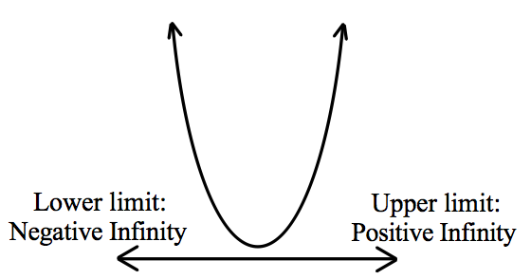  In words:  All real numbers ($R$)  As an inequality:  $$-∞<x<∞$$  As an interval:  $$(-∞, ∞)$$  Parabola Facing Down:  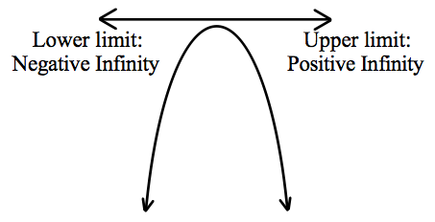  In words:  All real numbers ($R$)  As an inequality:  $$-∞<x<∞$$  As an interval:  $$(-∞, ∞)$$ | The ways that they’re written:  Parabola Facing Up:  In words:  Increasing over the interval of vertex x to infinity, and decreasing over the interval of negative infinity to vertex x.  As inequalities:  Increase: $vertex x<x<∞$  Decrease: $-∞<x<vertex x$  As intervals:  Increase: $(vertex x, ∞)$  Decrease: $(-∞, vertex x)$  Parabola Facing Down:  In words:  Increasing over the interval of negative infinity to vertex x, and decreasing over the interval of vertex x to negative infinity.  As inequalities:  Increase: $-∞<x<vertex x$  Decrease: $vertex x<x<∞$  As intervals:  Increase: $(-∞, vertex x)$  Decrease: $(vertex x, ∞)$ | The ways that it’s written:  Parabola Facing Up:  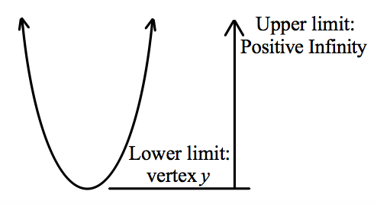  In words:  y will be greater than or equal to the vertex y-value  As an inequality:  $$y≥vertex y$$  As an interval:  $$[vertex y, ∞)$$  Parabola Facing Down:  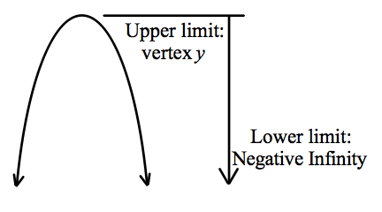  In words:  y will be less than or equal to the  vertex y-value  As an inequality:  $$y≤vertex y$$  As an interval:  $$(-∞, vertex y]$$

