Solving Trig with a Calculator

You’ve learned how to set up and simplify trig equations with the goal of determining the measure of a side or an angle. At this point, your answers look something like this:

|  |  |  |
| --- | --- | --- |
| $$x=\frac{cos(38˚)}{9}$$ | $$x=\frac{4}{tan\left(47˚\right)}$$ | $$\sin\left(x˚\right)=\frac{5}{2}$$*Which, when solved for x is: $$x˚=\sin^{-1}\left(\frac{5}{2}\right)$$* |

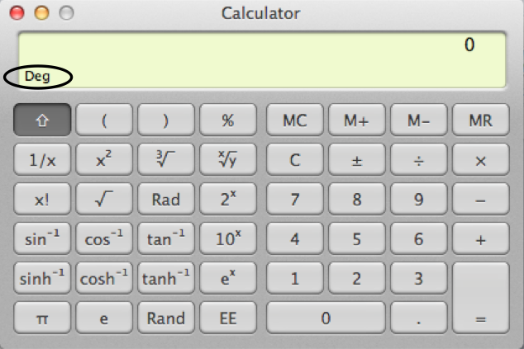The final step to solving trig problems is learning how to translate these answers into numbers. **If you’re using a calculator**, you can simply plug in your solution and push “=”. However, there are a few things you need to check on your calculator first.

1) Make sure it is set on **DEGREE** mode.

If the display says, “RAD” or “GRAD,” you have to

switch it to “DEG” before getting started.

2) Test how your calculator functions. Is it a more advanced calculator that allows you to type in the

problem as written, or do you have to type it in in reverse order?

TEST: Type $tan22$ =

**If it displays 0.4040..,** then you can type in the problems as written.

**If it displays 22**, then clear your calculator and try typing 22tan=. Now, if you get 0.4040…,

then that means your calculator needs you to type the trig pieces of the solution backwards.

Calculating a problem on the more advanced calculators:

$$x=\frac{5}{(sin\left(30˚\right))}→\boxed{5}\boxed{÷}\boxed{(} \boxed{sin(} \boxed{2} \boxed{0} \boxed{)} \boxed{)}\boxed{=}$$

*Parentheses are your friends, they keep your calculator from misunderstanding you. Don’t be afraid to use them.*

Calculating a problem *without* an advanced calculator:

$$\frac{5}{(sin\left(30˚\right))}→\boxed{5}\boxed{÷}\boxed{(} \boxed{2} \boxed{0} \boxed{sin} \boxed{)}\boxed{=}$$

**Evaluate *x*. Round your answer to the nearest tenth (one decimal place).**

|  |  |  |  |
| --- | --- | --- | --- |
| **EXAMPLE $$x=9cos(82˚)$$**  Type in: $$\boxed{3} \boxed{x} \boxed{(} \boxed{cos(} \boxed{8} \boxed{2} \boxed{)} \boxed{)}\boxed{=}$$ or $$\boxed{3} \boxed{x} \boxed{(} \boxed{8} \boxed{2} \boxed{cos} \boxed{)} \boxed{=}$$ Display reads: 1.25…  1.25 rounds up to $\boxed{1.3}$ | **EXAMPLE $$x=\frac{8}{sin\left(34˚\right)}$$**  Type in: $$\boxed{8}\boxed{÷}\boxed{(} \boxed{sin(} \boxed{3} \boxed{4} \boxed{)} \boxed{)}\boxed{=}$$ or $$\boxed{8} \boxed{÷} \boxed{(} \boxed{3} \boxed{4} \boxed{sin} \boxed{)}\boxed{=}$$ Display reads: 14.30…  14.30 doesn’t round up, so the answer is $\boxed{14.3}$ | **EXAMPLE $$x=\tan^{-1}\left(\frac{2}{3}\right)$$**  Type in: $$\boxed{shift} \boxed{tan⁡(} \boxed{2} \boxed{÷} \boxed{3} \boxed{)}\boxed{=}$$ or $$\boxed{2nd} \boxed{tan(} \boxed{2} \boxed{÷} \boxed{3} \boxed{)}\boxed{=}$$ or $$\boxed{(} \boxed{2} \boxed{÷} \boxed{3} \boxed{)} \boxed{shift} \boxed{tan}\boxed{=}$$ or $$\boxed{(} \boxed{2} \boxed{÷} \boxed{3} \boxed{)} \boxed{2nd} \boxed{tan}\boxed{=}$$ Display reads: 41.81…  41.81 doesn’t round up, so the answer is $\boxed{41.8}$ | **EXAMPLE $$x=\cos^{-1}\left(\frac{4}{5}\right)$$**  Type in: $$\boxed{shift} \boxed{cos⁡(} \boxed{4} \boxed{÷} \boxed{5} \boxed{)}\boxed{=}$$ or $$\boxed{2nd} \boxed{cos(} \boxed{4} \boxed{÷} \boxed{5} \boxed{)}\boxed{=}$$ or $$\boxed{(} \boxed{4} \boxed{÷} \boxed{5} \boxed{)} \boxed{shift} \boxed{cos}\boxed{=}$$ or $$\boxed{(} \boxed{4} \boxed{÷} \boxed{5} \boxed{)} \boxed{2nd} \boxed{cos}\boxed{=}$$ Display reads: 7.37…  7.37 rounds up to $\boxed{7.4}$ |
| $$1. x=\frac{10}{cos\left(49˚\right)}$$ | $$2. \sin^{-1}\left(\frac{3}{13}\right)$$ | $$3. x=6tan(25˚)$$ | $$4. \cos^{-1}\left(\frac{5}{8}\right)$$ |

**Use a trigonometry equation to evaluate *x*. Round your answer to the nearest tenth.**

|  |  |  |
| --- | --- | --- |
| 5. | 6. | 7. |
| 8. | 9. | 10. |
| 11. | 12. | 13. |
| 14. | 15. | 16. |