Integrated II: Unit 1 Study Guide
- Simplify.  $$\left(5x^{2}-x+8\right)+(-9x-13)$$ | - Simplify.  $$\left(-2x^{2}+7x-4\right)+(8x^{2}-6)$$ | - Simplify.  $$\left(6x^{2}-5x-3\right)+(2x-5)$$
- Simplify.  $$\left(6x^{5}-2x^{2}\right)-(4x^{3}+5x^{2}-9)$$ | - Simplify.  $$\left(3x^{4}+5x^{3}\right)-(8x^{3}+6x^{2}-7)$$ | - Simplify.  $$\left(-2x^{2}-x\right)-(6x^{3}+2x^{2}-4x)$$
- Determine the product.  $$(x-8)(6x+5)$$ | - Determine the product.  $$(2x-7)(x-4)$$ | - Determine the product.  $$\left(x+12\right)(3x-2)$$
- Factor completely.  $$x^{2}+6x+8$$ | - Factor completely.  $$x^{2}-13x+40$$ | - Factor completely.  $$x^{2}-7x-18$$
- Factor completely.  $$x^{2}-36$$ | - Factor completely.  $$x^{2}-25$$ | - Factor completely.  $$9x^{2}-4$$
- Factor completely.  $$20x^{2}-45$$ | - Factor completely.  $$24x^{2}-54$$ | - Factor completely.  $$48x^{2}-75$$
- Determine if the relation below is linear or quadratic.  x y  1 6  2 -2  3 -3  4 3  5 16 | - Determine if the relation below is linear or quadratic.  x y  1 -2  2 2  3 6  4 10  5 14 | - Determine if the relation below is linear or quadratic.  x y  1 8.5  2 7  3 5.5  4 4  5 2.5
- The graph of a quadratic function is shown below. Identify each property listed.  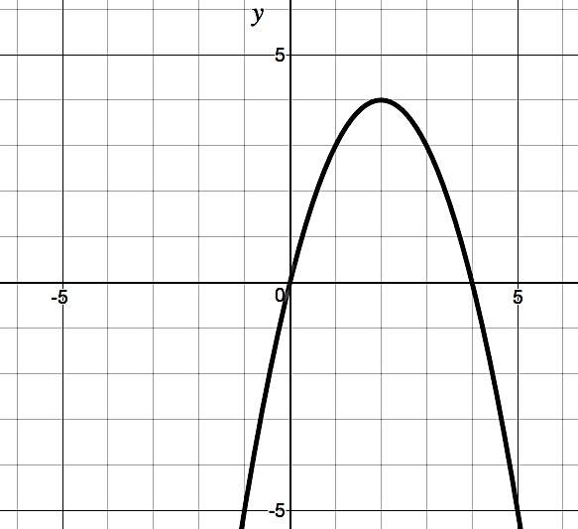  Domain: ____________________  Range: ____________________  Zeros: ____________________  Interval of Increase: ___________________  Interval of Decrease: __________________  x-intercept: ____________________  y-intercept: ____________________ | - The graph of a quadratic function is shown below. Identify each property listed.  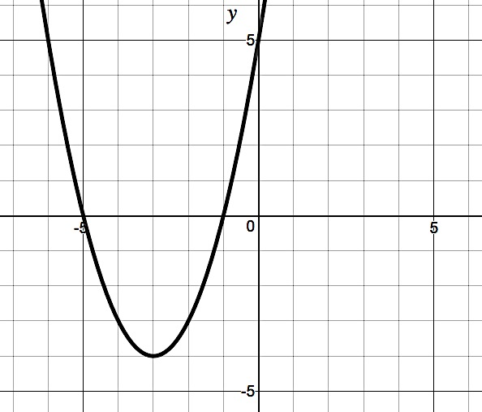  Domain: ____________________  Range: ____________________  Zeros: ____________________  Interval of Increase: ___________________  Interval of Decrease: __________________  x-intercept: ____________________  y-intercept: ____________________ | - The graph of a quadratic function is shown below. Identify each property listed.  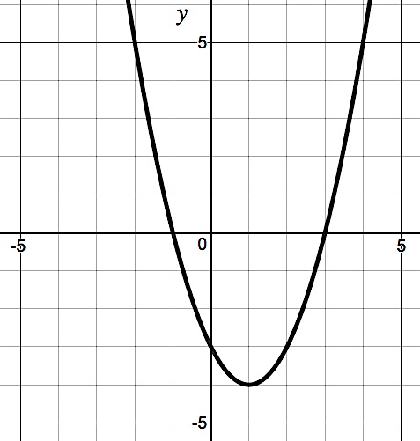  Domain: ____________________  Range: ____________________  Zeros: ____________________  Interval of Increase: ___________________  Interval of Decrease: __________________  x-intercept: ____________________  y-intercept: ____________________
- Find the roots of the quadratic function below.  $$f\left(x\right)=(x+9)(x-4)$$ | - Find the roots of the quadratic function below.  $$f\left(x\right)=-(x-6)(x+2)$$ | - Find the roots of the quadratic function below.  $$f\left(x\right)=(x)(x+7)$$
- Write the function below in factored form; then find the roots.$f\left(x\right)=5x^{2}-8x+3$ | - Write the function below in factored form; then find the roots. $f\left(x\right)=2x^{2}+13x+21$ | - Write the function below in factored form; then find the roots. $f\left(x\right)=4x^{2}-21x+5$
- Consider the function shown below.  $$f\left(x\right)=x^{2}+2x-8$$  - Find the vertex  - Is it an absolute maximum or minimum? Justify your answer. | - Consider the function shown below.  $$f\left(x\right)=x^{2}+6x+3$$  - Find the vertex  - Is it an absolute maximum or minimum? Justify your answer. | - Consider the function shown below.  $$f\left(x\right)=x^{2}+10x-2$$  - Find the vertex  - Is it an absolute maximum or minimum? Justify your answer.
- Graph the following quadratic function.  $$f\left(x\right)={\left(x+2\right)}^{2}-4$$  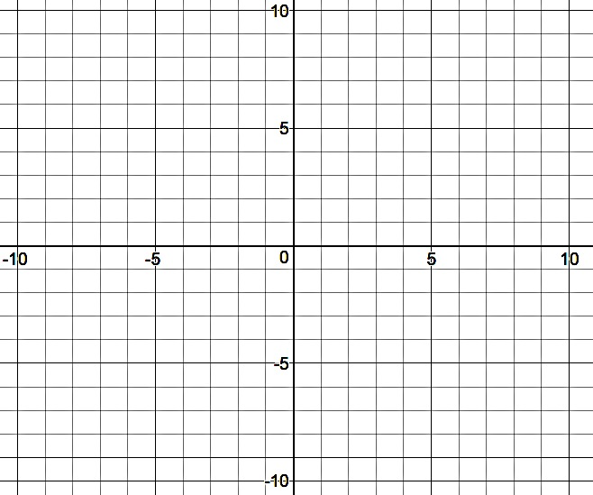 | - Graph the following quadratic function.  $$f\left(x\right)={-\left(x-3\right)}^{2}+4$$ | - Graph the following quadratic function.  $$f\left(x\right)={\left(x+5\right)}^{2}+9$$
- In the game Happy Acres, crops are planted for harvest. As players level up, the amount of time it takes for plants to be ready increases. On the first level, a plant takes 6 minutes. The second level takes 9 minutes, the third level 14 minutes, the fourth level 21 minutes and so on and so forth.  - Make a table that lists the level and the total minutes it takes.  - What type of function can model this situation? Explain how you can identify the function type.  - Write an equation that models the situation. | - Stacy is selling lemonade. Her parents gave her $3.00 to start the day. Each cup she sells makes her $0.50. On the first cup, her total profit is $3.50. On the second cup, it’s $4.00; the third is $4.50, the fourth $5.00, and so on and so forth.  - Make a table that lists the number of cups sold and the total profit Stacy makes.  - What type of function can model this situation? Explain how you can identify the function type.  - Write an equation that models the situation. | - A snail moves at a steady pace of 3 feet every minute. In one minute, it moves 3 feet. In two minutes, it moves 6 ft, three minutes is 9 ft, four is 12 ft, and so on and so forth.  - Make a table that lists the number of minutes and the total feet it moves.  - What type of function can model this situation? Explain how you can identify the function type.  - Write an equation that models the situation.

