Integrated II: Unit 1 Study Guide
- Find the value of $r$.  $${\left(r+4\right)}^{2}=48$$ | - Find the value of $s$.  $${\left(s-2\right)}^{2}=200$$ | - Find the value of $d$.  $${\left(d+3\right)}^{2}=12$$
- Determine the roots of the equation $x^{2}+5x-36=0$. | - Determine the roots of the equation $x^{2}-x-42=0$. | - Determine the roots of the equation $x^{2}-5x-14=0$.
- Calculate the roots of the quadratic equation, if possible. Verify your solution.  $$3x^{2}+10x+8=0$$ | - Calculate the roots of the quadratic equation, if possible. Verify your solution.  $$4x^{2}+10x+6=0$$ | - Calculate the roots of the quadratic equation, if possible. Verify your solution.  $$5x^{2}+7x-6=0$$
- Use the quadratic formula to find the zeros.  $$f\left(x\right)=-2x^{2}+4x-3$$ | - Use the quadratic formula to find the zeros.  $$f\left(x\right)=x^{2}-8x+1$$ | - Use the quadratic formula to find the zeros.  $$f\left(x\right)=-x^{2}-10x+9$$
- Graph. $f\left(x\right)=x^{2}-2x-3$  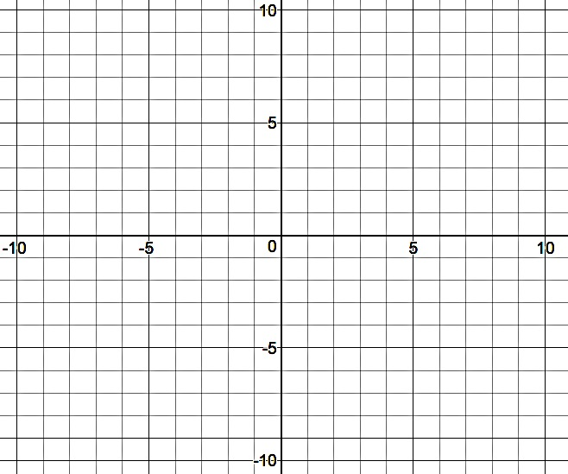 | - Graph. $f\left(x\right)=-x^{2}-6x-8$ | - Graph. $f\left(x\right)=-x^{2}-8x-7$
- Find the zeros and write them in interval notation.  $$f(x)<x^{2}-2x-3$$ | - Find the zeros and write them in interval notation.  $$f(x)≤-x^{2}-6x-8$$ | - Find the zeros and write them in interval notation.  $$f\left(x\right)≥-x^{2}-8x-7$$
- Solve the system of equations algebraically over the set of real numbers.  $$\left\{\begin{aligned}y=2x-5 \\ y=4x^{2}+10x-17\end{aligned}\right.$$ | - Solve the system of equations algebraically over the set of real numbers.  $$\left\{\begin{aligned}y=-3x+7 \\ y=2x^{2}+9x+7\end{aligned}\right.$$ | - Solve the system of equations algebraically over the set of real numbers.  $$\left\{\begin{aligned}y=5x+1 \\ y=3x^{2}+5x-11\end{aligned}\right.$$
- Simplify each expression by using $i$.  - $i^{47}$  - $\sqrt{-64}$  - $5+\sqrt{-147}$  - $(2+3i)(4-9i)$ | - Simplify each expression by using $i$.  - $i^{77}$  - $\sqrt{-169}$  - $2+\sqrt{-128}$  - $(5-i)(2+4i)$ | - Simplify each expression by using $i$.  - $i^{66}$  - $\sqrt{-625}$  - $7-\sqrt{-243}$  - $(11-2i)(5+3i)$
- List all words from the box that describe the number, $5+3i$.  Natural Number Whole Number Integer  Rational Number Irrational Number Real Number  Imaginary Number Complex Number | - List all words from the box that describe the number, $19.5$.  Natural Number Whole Number Integer  Rational Number Irrational Number Real Number  Imaginary Number Complex Number | - List all words from the box that describe the number, $\sqrt{7}$.  Natural Number Whole Number Integer  Rational Number Irrational Number Real Number  Imaginary Number Complex Number
- A ball on an unknown planet is tossed upward from a height of 84 feet with an initial vertical velocity of 7 feet per second. Its height can be modeled by the quadratic function  $h\left(t\right)=-7x^{2}+7x+84$, where $h\left(t\right)$is the height, in feet, of the ball, and $t$ is the time the ball has been in the air, in seconds.  - Determine the values of $a, b,$and$c$.  - How long will it take for the ball to reach the ground after it has been tossed? Round to the nearest hundredth.  - Find the maximum height the ball will reach. | - A ball on an unknown planet is tossed upward from a height of 60 feet with an initial vertical velocity of 48 feet per second. Its height can be modeled by the quadratic function  $h\left(t\right)=-12x^{2}+48x+60$, where $h\left(t\right)$is the height, in feet, of the ball, and $t$ is the time the ball has been in the air, in seconds.  - Determine the values of $a, b,$and$c$.  - How long will it take for the ball to reach the ground after it has been tossed? Round to the nearest hundredth.  - Find the maximum height the ball will reach. | - A ball on an unknown planet is tossed upward from a height of 88 feet with an initial vertical velocity of 22 feet per second. Its height can be modeled by the quadratic function  $h\left(t\right)=-11x^{2}+22x+88$, where $h\left(t\right)$is the height, in feet, of the ball, and $t$ is the time the ball has been in the air, in seconds.  - Determine the values of $a, b,$and$c$.  - How long will it take for the ball to reach the ground after it has been tossed? Round to the nearest hundredth.  - Find the maximum height the ball will reach.

Answers
- $r=-4±4\sqrt{3}$ | - $s=2±10\sqrt{2}$ | - $d=-3±2\sqrt{3}$
- $\left(-9, 0\right) or (4, 0)$ | - $\left(-6, 0\right) or (7, 0)$ | - $\left(7, 0\right) or (-2, 0)$
- $\left(-2, 0\right) or \left(-\frac{4}{3}, 0\right)$ or  $\left(-2, 0\right) or \left(-1.\overline{3}, 0\right)$ | - $\left(-\frac{3}{2}, 0\right)or (-1, 0)$ or  $\left(-1.5, 0\right) or (-1, 0)$ | - $\left(-2, 0\right) or \left(\frac{3}{5}, 0\right)$ or  $$\left(-2, 0\right) or \left(0.6, 0\right)$$
- $\left(1-2i\sqrt{2}, 0\right) or \left(1+2i\sqrt{2}, 0\right)$ | - $\left(4-\sqrt{15}, 0\right) or \left(4+\sqrt{15}, 0\right)$ | - $\left(-5-\sqrt{34}, 0\right) or \left(-5+\sqrt{34}, 0\right)$
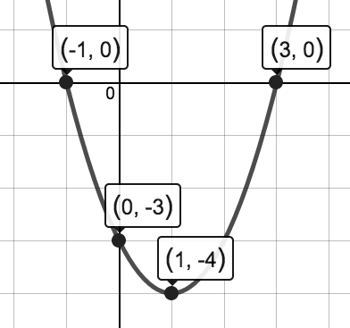 | 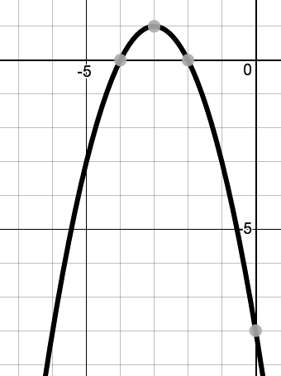  Vertex: $(-3, 1)$  Zeros: $\left(-4, 0\right) or (-2, 0)$  y-intercept: $(0, -8)$ | Vertex: $(-4, 9)$  Zeros: $\left(-7, 0\right) or (-1, 0)$  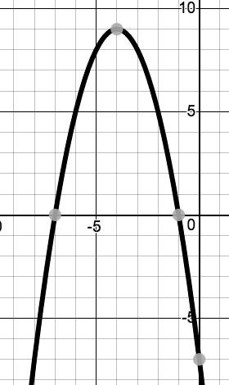  y-intercept: $(0, -7)$
- $\left(-∞, -1\right) or (3, ∞)$ | - $[-4, -2]$ | - $(-∞, -7] or [-1, ∞)$
- $\left(-3, -11\right) or (1, -3)$ | - $\left(0, 7\right) \& (-6, 25)$ | - $\left(2, 11\right) \& (-2, -9)$
- a. $i^{3}=\boxed{-i}$  b. $8i$  c. $5+7i\sqrt{3}$  d. $35-6i$ | - a. $i^{1}=\boxed{i}$  b. $13i$  c. $2+8i\sqrt{2}$  d. $14+18i$ | - a. $i^{2}=\boxed{-1}$  b. $25i$  c. $7-9\sqrt{3}$  d. $61+23i$
- Complex Number | - Rational, Real, & Complex Number | - Irrational, Real, & Complex Number
- a. $a=-7,b=7, c=84$  or, if you divided out the -7 first…  $$a=1,b=-1, c=-12$$  b. $\left(-3, 0\right) \& (4, 0)$  c. 85.75 feet  (Since the vertex is (0.5, 85.75), so the maximum is y = 85.75) | - a. $a=-12,b=48, c=60$  or, if you divided by the -12 first…  $$a=1,b=-4, c=-5$$  b. $\left(-1, 0\right) \& (5, 0)$  c. 108 feet  (Since the vertex is (2, 108), the maximum height is y = 108) | - a. $a=-11,b=22, c=88$  or, if you divided by the -11 first…  $$a=1,b=-2, c=-8$$  b. $\left(-2, 0\right) \& (4, 0)$  c. 99 feet  (Since the vertex is (1, 99), the maximum height is y = 99)

