(Part 1) Multiple Choice: Identify the choice that best completes the statement or answers the question.
- Determine the x-intercept for  $$f\left(x\right)=-3x^{2}+3x+18$$  A. $\left(2, 0\right) and (-3, 0)$  B. $\left(-2, 0\right) and (3, 0)$  C. $\left(0, -2\right) and (0, 3)$  D. $\left(-2, 0\right) and (-3, 0)$ | - Determine the axis of symmetry if the x-intercepts of the parabola are $(6, 0)$ and$(20, 0)$  A. $x=13$  B. $x=6$  C. $x=7$  D. $x=14$ | - Which function opens upward?  A. $f\left(x\right)=(x+3)(-4x-2)$  B. $f\left(x\right)=-(x+4)(x+5)$  C. $f\left(x\right)=-2{\left(x+7\right)}^{2}+4$  D. $f\left(x\right)=x^{2}-3x-8$ | - Which is the absolute maximum of the function $f\left(x\right)=x^{2}-14x$  A. $(-7, 49)$  B. $(7, -49)$  C. $(0, 0)$  D. $(-49, 7)$
- Which of these functions has a y-intercept of $(0, 4)$?  A. $f\left(x\right)=5x(x-4)$  B. $f\left(x\right)=4x^{2}+2x-3$  C. $f\left(x\right)=-x^{2}+3x+4$  D. $f\left(x\right)=4(x+2)(x-3)$ | - What is the range of the function represented by the graph?  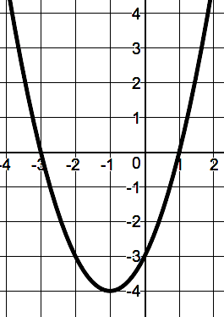  A. $y≥-4$  B. $y≤-3$  C. $y≥1$  D. $y≥-3$ | - How does this equation compare to the graph of $g\left(x\right)=x^{2}?$  $$h\left(x\right)={\left(x+5\right)}^{2}-3$$  A. It opens downward, and it is translated 5 units to the left and 3 units down.  B. It opens downward, and it is translated 5 units to the right and 3 units down.  C. It opens up, and it is translated 5 units to the left and 3 units down.  D. It opens up, and it is translated 5 units to the right and 3 units down. | - Determine the product.  $$(2x+7)(3x-5)$$  A. $6x^{2}+31x+35$  B. $6x^{2}+11x-35$  C. $6x^{2}+21x-35$  D. $6x^{2}-35$
- Simplify.  $$\left(4x^{6}-5x\right)-(3x^{2}-5x+3)$$  A. $4x^{6}-8x^{2}+5x-3$  B. $x^{4}-10x+3$  C. $4x^{4}+3x^{2}+3$  D. $4x^{6}-3x^{2}-3$ | - Which correctly factors the polynomial?  $$12x^{2}-5x-2$$  A. $(x+8)(x-3)$  B. $(x-8)(x+3)$  C. $(4x+1)(3x-2)$  D. $(4x-1)(3x+2)$ | - A park is in the shape of a square. The area of the park is 249 square meters. The exact length of a side of the park is between which two lengths?  A. 11 meters and 12 meters  B. 13 meters and 14 meters  C. 15 meters and 16 meters  D. 17 meters and 18 meters | - Which is equivalent to the radical expression?  $$\sqrt{135}$$  A. $3\sqrt{15}$  B. $5\sqrt{15}$  C. $3\sqrt{11}$  D. $5\sqrt{11}$
- Which correctly completes the square to solve the polynomial?  $$x^{2}-12x=32$$  A. $x^{2}-12x\boxed{+144}=32\boxed{+144}$  B. $x^{2}-12x\boxed{+24}=32\boxed{+24}$  C. $x^{2}-12x\boxed{+36}=32\boxed{+36}$  D. $x^{2}-12x\boxed{+6}=32\boxed{+6}$ | - Which polynomial does the graph represent?  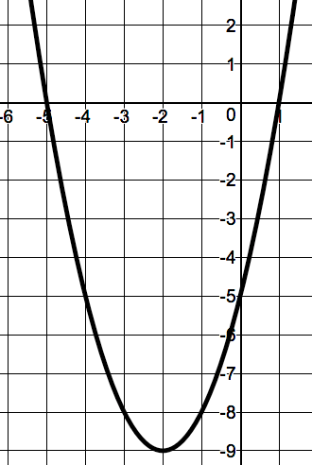  A. $y=(x-5)(x+1)$  B. $y=(x-5)(x-1)$  C. $y=(x+5)(x+1)$  D. $y=(x+5)(x-1)$ | - What are the zeros of the quadratic function?  $$f\left(x\right)=3x^{2}+9x-12$$  A. $x=1 or x=4$  B. $x=-1 or x=4$  C. $x=-1 or x=-4$  D. $x=1 or x=-4$ | - What are the solutions to this system of equations?  $$\left\{\begin{aligned}y=3x+13 \\ y=x^{2}+3\end{aligned}\right.$$  A. $\left(2, 7\right);(-5, 28)$  B. $\left(-2, 7\right);(5, 28)$  C. $\left(-2, -7\right);(5, 28)$  D. $\left(2, 7\right);(-5, -28)$
- What are the interval solutions to the quadratic inequality $-x^{2}-4x+12≤0$?  A. $(-6, 2)$  B. $[-6, 2]$  C. $\left(-∞, -6\right) or (2, ∞)$  D. $\left(-∞, -6\right] or [2, ∞)$ | - How many real solutions does the quadratic function $f\left(x\right)=5x^{2}+1$ have?  A. 0  B. 1  C. 2  D. Infinite | - What are the solutions to the system of equations shown?  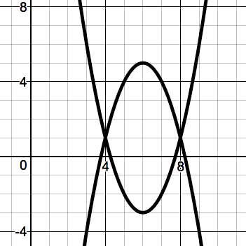  A. $\left(4, 2\right);(8, 2)$  B. $\left(4, 1\right);(8, 1)$  C. $\left(6, -3\right);(6, 5)$  D. $\left(1, 4\right);(1, 8)$ | - The point $(0, -9)$ identifies what feature of the graph below?  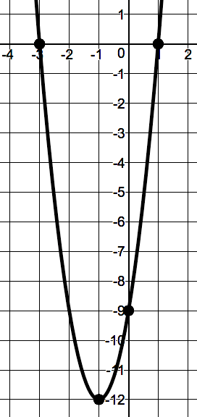  A. Vertex  B. Y-intercept  C. Axis of Symmetry  D. X-intercept
- What are the zeros of the equation function $f\left(x\right)=x^{2}-5x+7$?  A. $x=\frac{5±i\sqrt{3}}{2}$  B. $x=-\frac{5±i\sqrt{3}}{2}$  C. $x=\frac{5±3i}{2}$  D. $x=-\frac{5±3i}{2}$ | - What is the inverse of $f\left(x\right)=4x-5$?  A. $f^{-1}\left(x\right)=\frac{1}{4}x+\frac{1}{5}$  B. $f^{-1}\left(x\right)=-\frac{1}{4}x-\frac{1}{5}$  C. $f^{-1}\left(x\right)=\frac{1}{4}x+\frac{5}{4}$  D. $f^{-1}\left(x\right)=-\frac{1}{4}x-\frac{5}{4}$ | - Which of the following is NOT a one-to-one function?  A. $f\left(x\right)=8x$  B. $f\left(x\right)=8$  C. $f\left(x\right)=8x-7$  D. $f\left(x\right)=\frac{1}{8}x-\frac{7}{8}$ | - What is the inverse of the point $(9, -6)$?  A. $(9, -6)$  B. $(-9, 6)$  C. $(-6, 9)$  D. $(6, -9)$
(PART 2) Constructed Response: Show all work necessary to determining the solution.
- The graph represents the function  $f\left(x\right)=2x^{2}-20x+42$. Identify each of the properties listed.  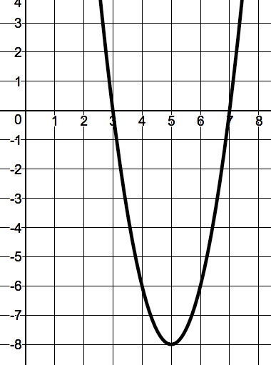  Domain: __________________________  Range: __________________________  Zeros: __________________________  Interval of increase: ______________  Interval of decrease: ______________ | - Show by drawing an area model or multiplication table how to find the product of $-2x+11$ and $5x+9$. Also, find the product of $-2x+11$ and $5x+9$.
- Sean was determining the roots for the quadratic equation $x^{2}+8x+3=-4$. His work is shown.  $$x^{2}+8x+3=-4$$  $$x^{2}+8x+7=0$$  $$a=1, b=8, c=7$$  $$x=\frac{-8±\sqrt{8^{2}-4\left(1\right)\left(7\right)}}{2(1)}$$  $$x=\frac{-8±\sqrt{64+28}}{2}$$  $$x=\frac{-8±\sqrt{92}}{2}=\frac{-8±2\sqrt{13}}{2}=-4+\sqrt{13} or-4-\sqrt{13}$$  The roots are $-4+\sqrt{13}$ or $-4-\sqrt{13}$  a. What did Sean do incorrectly when determining the roots?  b. Determine the roots for the given quadratic equation. | - Name each of the following for the quadratic function $h\left(x\right)=-x^{2}-6x+16$.  Zeros _____________________  y-intercept _____________________  Vertex _____________________

