Integrated Math II – Semester 1
Final Exam Review with Examples
Vertex - Axis of Symmetry, Minimum & Maximum
Axis of Symmetry Example:  Determine the axis of symmetry if the x-intercepts of the parabola are $(6, 0)$ and$\left(20, 0\right).$  The axis of symmetry is the x-value at the midpoint of any two symmetrical points. To find it, add up the x-values and divide by 2.  $$x=\frac{6+20}{2}=\frac{26}{2}=13$$  $$\boxed{x=13}$$ | Minimum/Maximum Example:  What is the absolute minimum of the function $f\left(x\right)=x^{2}-14x$?  The absolute min/max is part of the vertex. To find the x value of the vertex, use the formula$x=\frac{-b}{2a}$.  $$f\left(x\right)=x^{2}-14x→a=1, b=-14, c=0$$  $$x=\frac{-(-14)}{2(1)}=\frac{14}{2}=7 plug it in for y.$$  $$f\left(7\right)={\left(7\right)}^{2}-14\left(7\right)=49-98=-49$$  $$\boxed{The absolute minimum is (7,-49).}$$ | Vertex Example:  Name the vertex for the quadratic function $h\left(x\right)=-x^{2}-6x+16$.  $$x=\frac{-b}{2a}=\frac{-\left(-6\right)}{2\left(-1\right)}=\frac{6}{-2}=-3$$  $$h\left(-3\right)=-{\left(-3\right)}^{2}-6\left(-3\right)+16$$  $$h\left(-3\right)=-9+18+16$$  $$h\left(-3\right)=9+16$$  $$h\left(-3\right)=25$$  $\boxed{The vertex is: (-3, 25)}$.

1. Determine the axis of symmetry if the x-intercepts of the parabola are $(-4, 0)$ and$(32, 0)$. | 2. What is the absolute maximum of the function $f\left(x\right)=-x^{2}+8x$? | 3. Name the vertex for the quadratic function  $$h\left(x\right)=3x^{2}-12x+1$$

Features of a Quadratic Equation – Direction, Translation, Y-intercept, Interval Solutions
Y-Intercept Example 1:  Is $(0, 4)$ the y-intercept of the equation function $f\left(x\right)=-x^{2}+3x+4$? How do you know?  If you plug in the point $\left(0, 4\right)$, then you can check if the point is the correct y-intercept (if it works, it has to be a y-intercept because x = 0).  $$f\left(x\right)=-x^{2}+3x+4$$  $$4=-{\left(0\right)}^{2}+3(0)+4$$  $$4=-0+0+4$$  $$4=4$$  The equation works with the given point. $(0, 4)$ is the y-intercept.  Y-Intercept Example 2:  Name the y-intercept for the quadratic function $h\left(x\right)=-x^{2}-6x+16$.  $$h\left(0\right)=-{\left(0\right)}^{2}-6(0)+16$$  $$h\left(0\right)=-0-0+16$$  $$h\left(0\right)=16$$  $$\boxed{The y-intercept is (0, 16).}$$ | Direction & Transformation Example 1:  Does the function $f\left(x\right)=(x+3)(-4x-2)$ open upward or downward? How do you know?  Normally, the positive front is enough. However, both of the front terms $(x \&-4x)$ are not positive, so I have to multiply them and check the sign. Multiplying $\left(x\right)\left(-4x\right)$ makes $-4x^{2}$.  Since the first term ${(x}^{2})$ is negative, the parabola will open downward.  Direction & Transformation Example 2:  How does this equation compare to the graph of $g\left(x\right)=x^{2}?$  $$h\left(x\right)={\left(x+5\right)}^{2}-3$$  $x^{2}$ (the beginning) is positive, so it will $\boxed{open up}$. $(x+5)$ provides the translation left/right: since x lies, +5 means it moved $\boxed{left 5}$. The $-3$ at the end is the honest y translation up/down: $-3$ is $\boxed{down 3}$. | Interval Solutions Example:  What are the interval solutions to the quadratic inequality  $-x^{2}-4x+12≤0$?  A. $(-6, 2)$  B. $[-6, 2]$  C. $\left(-∞, -6\right) or (2, ∞)$  D. $\left(-∞, -6\right] or [2, ∞)$  I prefer to sketch it to see it better:  $-x^{2}$makes it face down  $≤0$, means that y is greater, so we shade up  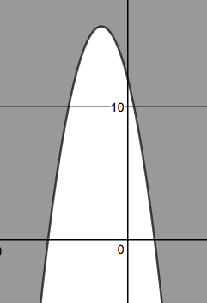  & $≤$ means it’s “or equal to,” so the answer will have [ ] where the numbers are.  Since the shading is on the outside, there are two shaded parts of x, which means the answer is:  $$\boxed{\left(-∞, -6\right] or [2, ∞)}$$

4. Does the function  $f\left(x\right)=(-3x+2)(-x-4)$ open upward or downward? How do you know? | 5. Is $(0, 2)$ the y-intercept of the function $f\left(x\right)=2x^{2}-4x-1$? Why or why not? |  | 6. How does this equation compare to the graph of $g\left(x\right)=x^{2}?$  $$h\left(x\right)=-{\left(x-4\right)}^{2}-2$$
7. What are the interval solutions to the quadratic inequality $x^{2}+9x+20<0$?  A. $(-5, -4)$ B. $[-5, -4]$  C. $\left(-∞, -5\right) or (-4, ∞)$ D. $\left(-∞, -5\right] or [-4, ∞)$ |  | 8. Name the y-intercept for the quadratic function  $h\left(x\right)=3x^{2}-5x+11$.
Features of a Quadratic Graph – Domain, Range, Intervals of Increase/Decrease, Zeros, Y-intercept, Vertex, Axis of Symmetry
What is the range of the function represented by the graph?  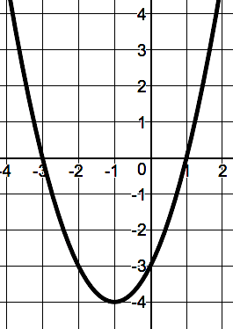  The range is all values that y can be. The lowest y is at $y=-4$. The rest of the graph is above the vertex point, $(-1, -4)$. So, the range is all values of y above or equal to $-4$.  $$\boxed{y≥-4}$$ | What is the simplest polynomial that the graph can represent?  $$y=(x )(x )$$  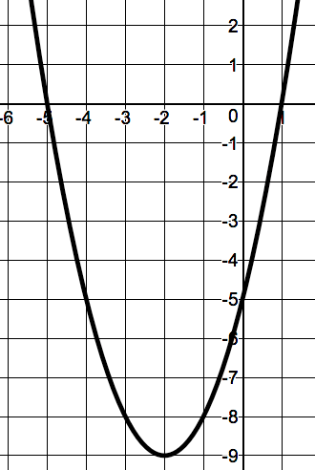  The zeros are at -5 & 1. The factors use their opposites: +5 & -1.  So, $\boxed{y=(x+5)(x-1)}$ | The point $(0, -9)$ identifies what feature of the graph below?  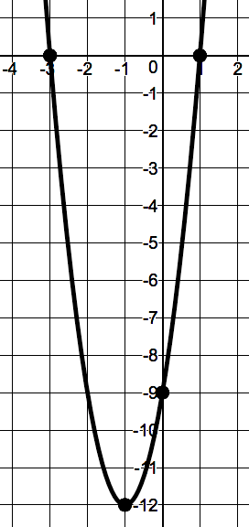  The vertex is the turning point: $(-1, -12)$.  The axis of symmetry is the x of the vertex: $x=-1$  The zeros are where it crosses x: $\left(3, 0\right) \& (1, 0)$  The y-intercept is where it crosses y: $(0, -9)$.  It’s the y-intercept. | The graph represents the function  $f\left(x\right)=2x^{2}-20x+42$. Identify the domain, range, zeros, interval of increase, and interval of decrease.  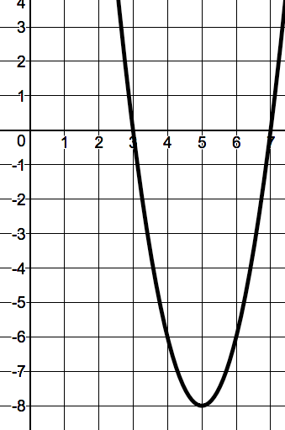  Domain is what x can be, and there is no limit, so it’s $\boxed{(-∞,∞)}$.  Range is what y can be, and the lowest point is at$y=-8$, so the range is $\boxed{[-4,∞)}$.  Zeros are $\boxed{\left(3, 0\right) \& (7, 0)}$.  Interval of Increase is where x starts and ends when the y is moving up, so it’s: $\boxed{(5,∞)}$.  Interval of Decrease is where x starts and ends when the y is moving down, so it’s: $\boxed{(-∞, 5)}$.

9. What is the range of the function represented by the graph?  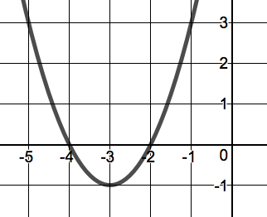 | 10. What is the simplest polynomial that the graph can represent?  $$y=(x )(x )$$ | 11. The point $(2, 3)$ identifies what feature of the graph below?  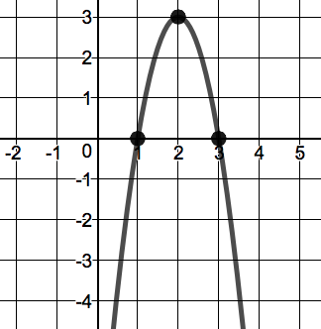 | 12. The graph represents the function  $f\left(x\right)=-3x^{2}+12x-9$. Identify the domain, range, zeros, interval of increase, and interval of decrease.

Zeros/X-intercepts/Roots/Quadratic Solutions – Quadratic Formula, Completing the Square, Factoring, Plugging in Values
Quadratic Formula Example 1:  What are the zeros of the equation function  $f\left(x\right)=x^{2}-5x+7$?  $$x^{2}-5x+7=0$$  $$a=1, b=-5, c=7$$  $$x=\frac{-(-5)±\sqrt{{(-5)}^{2}-4\left(1\right)\left(7\right)}}{2(1)}$$  $$x=\frac{5±\sqrt{25-28}}{2}$$  $$x=\frac{5±-\sqrt{3}}{2}=\frac{5±i\sqrt{3}}{2}$$  $$\boxed{The roots are \frac{5+i\sqrt{3}}{2}or \frac{5-i\sqrt{3}}{2}}$$  Example 2:  How many real solutions does the quadratic function $f\left(x\right)=5x^{2}+1$ have?  $${5x}^{2}+0x+1=0$$  $$a=5, b=0, c=1$$  $$x=\frac{-(0)±\sqrt{{(0)}^{2}-4\left(5\right)\left(1\right)}}{2(5)}=\frac{0±\sqrt{0-20}}{10}=\frac{0±\sqrt{-20}}{10}$$  The radical part tells us how many zeros a quadratic will have: $±\sqrt{-20}$ means that we will add or subtract (2 answers) an imaginary number, so there are $\boxed{0 real solutions}$  The rules:  $$±\sqrt{+number}=2 real answers$$  $$±\sqrt{0}=1 real answer$$  $$±\sqrt{-number}=0 real answers$$ | Completing the Square Example 1:  How do you correctly complete the square to solve the polynomial?  $$x^{2}-12x=32$$  Step 1: To complete the square, make it = 0, then move all the numbers to the other side of the equal sign (already happened in this case: $x^{2}-12x-32=0 became x^{2}-12x=32$)  Step 2: Complete the square by adding ${\left(\frac{b}{2}\right)}^{2}$to both sides.  $$x^{2}-12x\boxed{+{\left(\frac{b}{2}\right)}^{2}}=32\boxed{+{\left(\frac{b}{2}\right)}^{2}}$$  $$x^{2}-12x\boxed{+{\left(\frac{-12}{2}\right)}^{2}}=32\boxed{+{\left(\frac{-12}{2}\right)}^{2}}$$  $$x^{2}-12x\boxed{+{\left(-6\right)}^{2}}=32\boxed{+{\left(-6\right)}^{2}}$$  $$x^{2}-12x\boxed{+36}=32\boxed{+36}$$  Step 3: Factor the left and simplify the right.  $$x^{2}-6x-6x+36=32+36$$  $$x\left(x-6\right)-6\left(x-6\right)=68$$  $$(x-6)\left(x-6\right)=68$$  Step 4: Write as a square, square root both sides & solve for x.  $${\left(x-6\right)}^{2}=68$$  $$±\sqrt{{\left(x-6\right)}^{2}}=±\sqrt{68}$$  $$(x-6)=±\sqrt{4}\sqrt{17}$$  $$x-6=±2\sqrt{17}$$  $$x=6±2\sqrt{17}$$  Example 2:  What would complete the square to solve the polynomial?  $$x^{2}-40x\boxed{+ }=-3\boxed{+ }$$  $$b=-40$$  $${\left(\frac{b}{2a}\right)}^{2}={\left(\frac{-40}{2(1)}\right)}^{2}={\left(\frac{-40}{2}\right)}^{2}={\left(-20\right)}^{2}=400$$  $$x^{2}-40x\boxed{+400}=-3\boxed{+400}$$
Factoring Example:  Determine the x-intercept for  $$f\left(x\right)=-3x^{2}+3x+18$$  Step 1: Factor out any number that all terms have (take out a, if you can)  $$f\left(x\right)=-3({1x}^{2}-1x-6)$$  Step 2: What 2 numbers multiply to AC & add to B?  $$AC=\left(1\right)\left(-6\right)=-6 \& B=-1$$  $3 \&-2$ multiply to $-6$ & add to $-1$  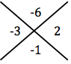  Step 3: Split the middle term, using the numbers from step 2.  $$f\left(x\right)=-3(x^{2}-3x+2x-6)$$  Step 4: Factor out shared values to create 2 common groups.  $$f\left(x\right)=-3(x\left(x-3\right)+2\left(x-3\right))$$  Step 5: Factor out the common group.  $$f\left(x\right)=-3(x-3)(x+2)$$  Step 6: Set = 0 and solve.  $$-3\left(x-3\right)\left(x+2\right)=0→x-3=0 or x+2=0$$  $$\boxed{x=3 or x=-2}$$ | Plugging in Answer Choices Example:  What are the zeros of the quadratic function?  $$f\left(x\right)=3x^{2}+9x-12$$  A. $x=1 or x=4$  B. $x=-1 or x=4$  C. $x=-1 or x=-4$  D. $x=1 or x=-4$  Test A. $x=1 or x=4$ $(f\left(x\right) should be 0)$  $f\left(1\right)=3{\left(1\right)}^{2}+9(1)-12$ $f\left(4\right)=3{\left(4\right)}^{2}+9(4)-12$  $f\left(1\right)=3(1)+9-12$ $f\left(4\right)=3(16)+36-12$  $f\left(1\right)=3-3=0✓$ $f\left(4\right)=48+24=72✗$  It must be $x=1$, so I will check D.  Test D. $x=1 or x=-4$ $(f\left(x\right) should be 0)$  $f\left(1\right)=0✓$ $f\left(-4\right)=3{\left(-4\right)}^{2}+9(-4)-12$  $f\left(-4\right)=3\left(16\right)-36-12$  $f\left(-4\right)=48-48=0✓$  $$\boxed{D. x=1 or x=-4}$$

13. Determine the x-intercept for $f\left(x\right)=2x^{2}+x-28$. | 14. What correctly completes the square to solve the polynomial?  $$x^{2}+22x\boxed{+ }=32\boxed{+ }$$ | 15. What are the zeros of the quadratic function?  $$f\left(x\right)=4x^{2}-1$$
16. How many real solutions does the quadratic function $f\left(x\right)=-x^{2}+3x+2$ have? | 17. What are the zeros of the equation function  $f\left(x\right)=x^{2}+4x+6$? | 18. Name the zeros of the quadratic function  $h\left(x\right)=x^{2}+10x+9$.

Polynomial Operations – Multiplication, Checking Factors, Combining Like Terms
Combining Like Terms Example:
Simplify. $\left(4x^{6}-5x\right)-(3x^{2}-5x+3)$

First, if one of the $( ) is -$, change every sign inside to its opposite: $\left(4x^{6}-5x\right)\boxed{+}(\boxed{-}3x^{2}\boxed{+}5x\boxed{-}3)$
Then, combine terms that have matching x exponents: $4x^{6} \& nothing,$ $-5x \&+5x, -3x^{2}\& nothing, -3 \& nothing$
$$4x^{6}-5x+5x-3x^{2}-3$$
$$\boxed{4x^{6}-3x^{2}-3}$$

Product Example 1:  Determine the product.  $$(2x+7)(3x-5)$$  $$2x$$ $$7$$  $$3x$$ $$6x^{2}$$ $$21x$$  $$-5$$ $$-10x$$ $$-35$$  $$6x^{2}+21x-10x-35$$  $$\boxed{6x^{2}+11x-35}$$ | Product Example 2:  Show by drawing an area model or multiplication table how to find the product of $-2x+11$ & $5x+9$. Also, find the product of $-2x+11$ & $5x+9$.  $$-2x$$ $$+11$$  $$5x$$ $$-10x^{2}$$ $$55x$$  $$+9$$ $$-18x$$ $$99$$  $$10x^{2}+55x-18x+99$$  $$\boxed{10x^{2}+37x+99}$$ | Checking Factors Example:  Does $(4x-1)(3x-2)$ correctly factor the polynomial? Show why or why not.  $$12x^{2}-5x-2$$  Check by multiplying:  $$4x$$ $$-1$$  $$3x$$ $$12x^{2}$$ $$-3x$$  $$-2$$ $$-8x$$ $$1$$  $$12x^{2}-3x-8x+1$$  $$\boxed{12x^{2}-11x+1}$$

19. Determine the product.  $$(5x-3)(-2x+11)$$ | 20. Simplify.  $$\left(x^{5}-4x\right)-(-2x^{5}+4x-1)$$ | 21. Does $(2x+1)(7x-4)$ correctly factor the polynomial? Show why or why not.  $$14x^{2}-4$$ | 22. Show by drawing an area model or multiplication table how to find the product of $6x-3$ and $-4x+5$. Also, find the product of $6x-3$ and $-4x+5$.

Systems of Equations – Checking Points
Checking Points in a System Example:  Are $\left(-2, 7\right) \& (-5, 28)$ solutions to this system of equations?  $$\left\{\begin{aligned}y=3x+13 \\ y=x^{2}+3\end{aligned}\right.$$  Check both points in both equations to see if they work.  $$\left(-2, 7\right)$$ $$\left(-2, 7\right)$$ $$(-5, 28)$$ $$(-5, 28)$$  $$y=3x+13$$ $$=3\left(-2\right)+13$$ $$=-6+13$$ $$=7$$ $$y=x^{2}+3$$ $$={(-2)}^{2}+3$$ $$=4+3$$ $$=7$$ $$y=3x+13$$ $$=3\left(-5\right)+13$$ $$=-15+13$$ $$=-2$$ $$y=x^{2}+3$$ $$={(-5)}^{2}+3$$ $$=25+3$$ $$=28$$  CORRECT! CORRECT! WRONG! CORRECT!  The second point doesn’t work in both equations,  so it is $\boxed{not a solution to the system}$. | System of Equation Graph Example:  What are the solutions to the system of equations shown?  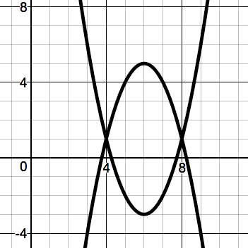  The solution is where the graphs intersect: $\boxed{\left(4, 1\right) \& (8, 1)}.$

23. Are $\left(-7,-16\right) \& (1, 0)$ solutions to this system of equations?  $$\left\{\begin{aligned}y=2x-2 \\ y=x^{2}+8x-9\end{aligned}\right.$$ | 24. What are the solutions to the system of equations shown?  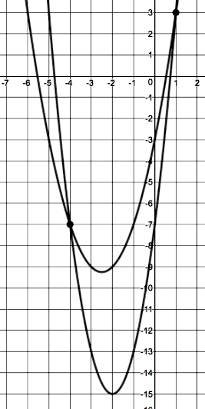
Radicals – Approximating, Simplifying
Approximating Square Roots Example:  A park is in the shape of a square. The area of the park is 249 square meters. The exact length of a side of the park is between which two lengths?  If the park is a square, then the sides are $\sqrt{249}$. The two perfect squares that 249 is between are ${15}^{2}=225$ & ${16}^{2}=256$. This means that $\sqrt{249}$ is between $\sqrt{225}$ & $\sqrt{256}$.  $$\boxed{The sides of the park are between 15 \& 16 meters.}$$ | Simplifying a Square Root Example:  Which is equivalent to the radical expression?  $$\sqrt{135}$$  $$Check if you can divide by any perfect squares:$$  $$4, 9, 16, 25, 36, 49, 64, 81, 100, 121$$  It’s not even, and it can’t be more than ½ the value, so that eliminates most choices:$4, 9, 16, 25, 36, 49, 64, 81, 100, 121$  $$135÷9=15, so \sqrt{135}=\sqrt{9}\sqrt{15}=\boxed{3\sqrt{15}}$$

25. A ballroom is in the shape of a square. The area of the ballroom is 31 square meters. The exact length of a side of the ballroom is between which two lengths? | 26. Which is equivalent to the radical expression?  $$\sqrt{124}$$

Inverse – Inverse Equations, Points, and One-to-one Functions
Inverse Equation Example:  What is the inverse of $f\left(x\right)=4x-5$?  Switch x & y, then solve to isolate y.  $$y=4x-5→x=4y-5$$  $$x+5=4y$$  $$\frac{x+5}{4}=\frac{4y}{4}$$  $$\frac{x+5}{4}=y$$  $$\frac{1}{4}x+\frac{5}{4}=y$$  $$y=\frac{1}{4}x+\frac{5}{4}$$  $$\boxed{f^{-1}(x)=\frac{1}{4}x+\frac{5}{4}}$$ | Inverse Point Example:  What is the inverse of the point $(9, -6)$?  Switch x & y.  $$(9, -6)→\boxed{(-6, 9)}$$ | One-to-One Function Example:  Is $f\left(x\right)=8x-7$ a one-to-one function?  Draw a sketch. If it’s one-to one, then it will pass the vertical and the horizontal line test.  Use your pen as a line. Hold it vertically and drag it across the graph. If it always goes through only 1 point, then it passes the 1st test. Try it horizontally. If it passes that too, it’s one-to-one.  $f\left(x\right)=8x-7$ $\boxed{is}$ a one-to-one function.

27. What is the inverse of  $f\left(x\right)=9x+17$? | 28. What is the inverse of the point $(-12, 4)$? | 29. Is $x=-11$ a one-to-one function?

Integrated Math II – Semester 1
Final Exam Review with Examples

Answers

- $x=14$ | - $(4, 16)$ | - $(2, -11)$ | - It faces up because $\left(-3x\right)\left(-x\right)=+3x^{2}$, so the $x^{2}$ term is positive.
- No. The constant term is not 2. If you plug in 0, the y-intercept will be -1. | - It opens downward and has been translated right 4 and down 2. | - $C. \left(-∞, -5\right) or (-4, ∞)$ | - $(0,11)$
- $y≥-1$ | - $y=(x+4)(x+2)$ | - Vertex | - Domain: $(-∞,∞)$  Range: $(-∞,3)$ or $y≤3$  Zeros: $\left(1, 0\right) \& (3,0)$  Increase: $(-∞,2)$  Decrease: $(2,∞)$
- $x=-4 or x=\frac{7}{2}$ | - $\boxed{+121}$ | - $\left(-\frac{1}{2},0\right)\& \left(\frac{1}{2},0\right)$ | - 2 real solutions
- $-2±i\sqrt{2}$ | - $\left(-9,0\right) \& (-1,0)$ | - $-10x^{2}+61x-33$ | - $3x^{5}-8x+1$
- If you multiply$\left(2x+1\right) \& (7x-4)$, you will get $14x^{2}-x-4$, which $≠14x^{2}-4$. So, no. They are not the factors. | $$6x$$ $$-3$$  $$-4x$$ $$-24x^{2}$$ $$+12x$$  $$+5$$ $$30x$$ $$-15$$  $$-24x^{2}+12x+30x-15$$  $$-24x^{2}+42x-15$$ | - Yes. | - $\left(1, 3\right) \& (-4, -7)$
- Between 5 & 6 meters | - $2\sqrt{31}$ | - $y=\frac{1}{9}x-\frac{17}{9}$ | - $(4, -12)$
- No.

