Logic Puzzles

1.
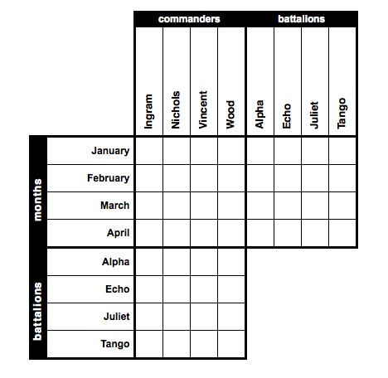 | Match each army battalion to its commander, and determine the month and location of their next deployment. Remember, as with all grid-based logic puzzles, no option in any category will ever be used more than once.  Clues  1. The battalion led by Commander Vincent will deploy 1 month after Echo Battalion.  2. The battalion led by Commander Wood will deploy 1 month before Echo Battalion.  3. Juliet Battalion will deploy 1 month before the battalion led by Commander Ingram.  4. The battalion led by Commander Nichols is Tango Battalion.  5. The four battalions are the battalion led by Commander Wood, the battalion deploying in April, the battalion deploying in February and the battalion deploying in March.

2.
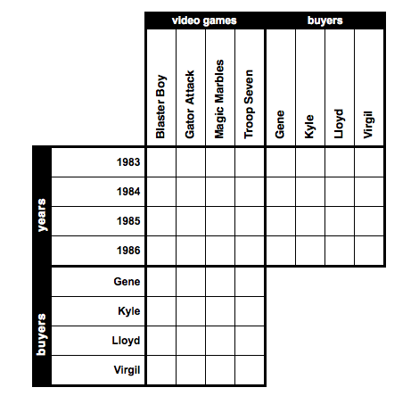 | Max has sold several of his "classic" video games this week via online auctions. Match each game to the year it came out and determine who bought it and for how much.  Clues  1. Blaster Boy came out in 1986.  2. The video game bought by Gene came out 1 year after the video game bought by Kyle.  3. Magic Marbles came out sometime before Troop Seven.  4. The game bought by Lloyd came out 2 years after Magic Marbles.  5. The game bought by Gene came out sometime before Gator Attack.

3.
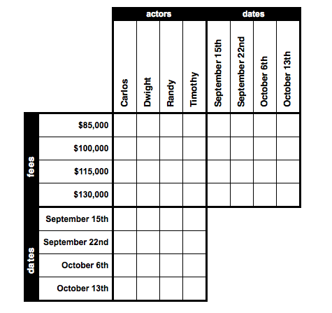 | Delilah DeLuca, the award-winning film director, has just finished casting her newest project. Help her set the schedule by matching each actor to his role, acting fee and film date.  Clues  1. Timothy will film on October 13th.  2. The man filming on October 13th will make 15,000 dollars more than Dwight.  3. The person filming on October 6th will make 15,000 dollars less than the actor filming on September 22nd.  4. The man filming on October 13th will make 15,000 dollars less than the man filming on October 6th.  5. Carlos will film on October 6th.

4.
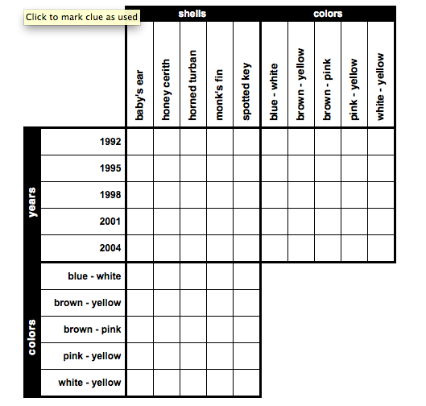 | Mika is quite proud of her little shell collection. Match each shell's name to its primary colors and the year and place in which Mika found it.  1. The horned turban shell was found 6 years before the white and yellow seashell.  2. The five shells are the seashell found in 2004, the brown and pink seashell, the brown and yellow shell, the baby's ear shell and the horned turban shell.  3. The pink and yellow seashell was found sometime after the monk's fin shell.  4. The monk's fin shell is either the seashell found in 1998 or the shell found in 1995.  5. The monk's fin shell was found 6 years before the brown and pink seashell.  6. The baby's ear shell was found sometime after the horned turban shell.  7. The honey cerith shell wasn't found in 2004.

ANSWERS:

1.
Months | Commanders | Battalions
January | Wood | Juliet
February | Ingram | Echo
March | Vincent | Alpha
April | Nichols | Tango

2.
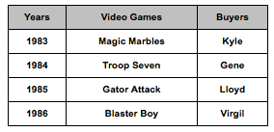

3.
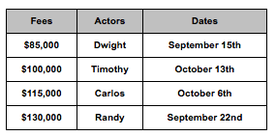

4.
