Mid-Unit 1 Skills Practice: Quadratics
Example  Factor.  $$-9x^{2}-6x+6x+4$$ | - Factor. $2x^{2}+8x-3x-12$ | - Factor. $7x^{2}+14x+5x+10$
 | - Factor. $-6x^{2}+15x+4x-10$ | - Factor. $8x^{2}-2x+4x-1$
Example  Factor.  $4x^{2}-8x+$3  First, split -8x into two numbers that multiply to equal the first (+4) times the last (+3), and also add up to -8x  $$4x^{2}_______________________+3$$ | - Factor. $x^{2}+11x+30$ | - Factor. $-4x^{2}-9x+9$
 | - Factor. $5x^{2}+12x+4$ | - Factor. $-3x^{2}+22x-7$
Example  Fill in the first and second differences, and identify the function as either linear or quadratic.  $$x$$ $$y$$  -2 4.3 1st  2nd  -1 11.4  0 15.5  1 16.6  2 14.5  Function type: _________________________ | - Fill in the first and second differences, and identify the function as either linear or quadratic.  $$x$$ $$y$$  -2 9 1st  2nd  -1 8  0 5  1 0  2 -7  Function type: _________________________ | - Fill in the first and second differences, and identify the function as either linear or quadratic.  $$x$$ $$y$$  -2 -6 1st  2nd  -1 -10.4  0 -14.8  1 -19.2  2 -23.6  Function type: _________________________
Example  Fill in the first and second differences, and identify the function as either linear or quadratic.  $$x$$ $$y$$  -2 11.5 1st  2nd  -1 9  0 6.5  1 4  2 1.5  Function type: _________________________ | - Fill in the first and second differences, and identify the function as either linear or quadratic.  $$x$$ $$y$$  -2 2 1st  2nd  -1 -1  0 1  1 8  2 20  Function type: _________________________ | - Fill in the first and second differences, and identify the function as either linear or quadratic.  $$x$$ $$y$$  -2 -11.3 1st  2nd  -1 -10.3  0 -1.3  1 16.3  2 41.3  Function type: _________________________
Example  $$f\left(x\right)=x^{2}-8x-9$$  The axis of symmetry is $x=4$  Determine the vertex. | - $f\left(x\right)=x^{2}+6x+2$  The axis of symmetry is $x=-3$  Determine the vertex. | - $f\left(x\right)=-x^{2}+4x+32$  The axis of symmetry is $x=2$  Determine the vertex.
 | - $f\left(x\right)=x^{2}-12x+4$  The axis of symmetry is $x=6$  Determine the vertex. | - $f\left(x\right)=x^{2}-2x-1$  The axis of symmetry is $x=1$  Determine the vertex.
Example  $$f\left(x\right)=-x^{2}-8x-5$$  The axis of symmetry is $x=-4$  Determine the vertex. | - $f\left(x\right)=-x^{2}+20x-31$  The axis of symmetry is $x=10$  Determine the vertex. | - $f\left(x\right)=-x^{2}-4x+6$  The axis of symmetry is $x=-2$  Determine the vertex.
 | - $f\left(x\right)=-x^{2}+12x+3$  The axis of symmetry is $x=6$  Determine the vertex. | - $f\left(x\right)=x^{2}+8x-9$  The axis of symmetry is $x=-4$  Determine the vertex.
Example  a.) Write the quadratic in factored form.  b.) Identify whether the parabola opens upward or downward.  c.)Identify the x-intercepts.  $$f\left(x\right)=x^{2}+x-6$$ | - a.) Write the quadratic in factored form.  b.) Identify whether the parabola opens upward or downward.  c.)Identify the x-intercepts.  $$g\left(x\right)=-x^{2}-4x+5$$ | - a.) Write the quadratic in factored form.  b.) Identify whether the parabola opens upward or downward.  c.)Identify the x-intercepts.  $$h\left(x\right)=x^{2}+10x+16$$
Example  a.) Write the quadratic in factored form.  b.) Identify whether the parabola opens upward or downward.  c.)Identify the x-intercepts.  $$k\left(x\right)=-x^{2}+9$$ | - a.) Write the quadratic in factored form.  b.) Identify whether the parabola opens upward or downward.  c.)Identify the x-intercepts.  $$m\left(x\right)=x^{2}-25$$ | - a.) Write the quadratic in factored form.  b.) Identify whether the parabola opens upward or downward.  c.)Identify the x-intercepts.  $$n\left(x\right)=-x^{2}+8x-15$$
Example  Domain:  Range:  Zeros:  Intervals  Increase:  Decrease:  x-intercept:  y-intercept: | Domain:  Range:  Zeros:  Intervals  Increase:  Decrease:  x-intercept:  y-intercept: | Domain:  Range:  Zeros:  Intervals  Increase:  Decrease:  x-intercept:  y-intercept:
Example  Domain:  Range:  Zeros:  Intervals  Increase:  Decrease:  x-intercept:  y-intercept: | Domain:  Range:  Zeros:  Intervals  Increase:  Decrease:  x-intercept:  y-intercept: | Domain:  Range:  Zeros:  Intervals  Increase:  Decrease:  x-intercept:  y-intercept:
Example  $$f\left(x\right)=x^{2}+2x-3$$  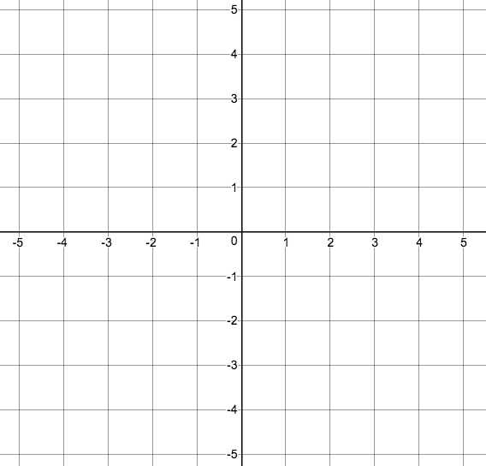  a.) Determine and plot the y-intercept  b.) Write the function in factored form.  c.) Determine and plot the x-intercepts  d.) Determine the axis of symmetry  e.) Determine the vertex  f.) Graph the vertex  g.) Graph the curve. | $$g\left(x\right)=x^{2}-4x+3$$  a.) Determine and plot the y-intercept  b.) Write the function in factored form.  c.) Determine and plot the x-intercepts  d.) Determine the axis of symmetry  e.) Determine the vertex  f.) Graph the vertex  g.) Graph the curve. | $$h\left(x\right)=-x^{2}+4x$$  a.) Determine and plot the y-intercept  b.) Write the function in factored form.  c.) Determine and plot the x-intercepts  d.) Determine the axis of symmetry  e.) Determine the vertex  f.) Graph the vertex  g.) Graph the curve.
Example  $$k\left(x\right)=-3x^{2}+3$$  a.) Determine and plot the y-intercept  b.) Write the function in factored form.  c.) Determine and plot the x-intercepts  d.) Determine the axis of symmetry  e.) Determine the vertex  f.) Graph the vertex  g.) Graph the curve. | $$m\left(x\right)={2x}^{2}-8x+6$$  a.) Determine and plot the y-intercept  b.) Write the function in factored form.  c.) Determine and plot the x-intercepts  d.) Determine the axis of symmetry  e.) Determine the vertex  f.) Graph the vertex  g.) Graph the curve. | $$n\left(x\right)=x^{2}-4$$  a.) Determine and plot the y-intercept  b.) Write the function in factored form.  c.) Determine and plot the x-intercepts  d.) Determine the axis of symmetry  e.) Determine the vertex  f.) Graph the vertex  g.) Graph the curve.

