Solving Systems of Quadratic Equations
Solve each system below using the following steps:
EXAMPLE | $$\left\{\begin{aligned}y=3x+1 \\ y=x^{2}+6x+1\end{aligned}\right.$$
- Set the two equations equal to each other | $$x^{2}+6x+1=3x+1$$
- Move everything from the right to the left side of the equation so that it will be equal to zero | $$x^{2}+6x\boxed{-3x}+1\boxed{-1}=3x\boxed{-3x}+1\boxed{-1}$$  $$x^{2}+3x+0=0$$
- Use the quadratic formula (or completing the square, or factoring) to solve for x. | $$x=\frac{-b±\sqrt{b^{2}-4ac}}{2a}$$  $$x=\frac{-(3)±\sqrt{{(3)}^{2}-4(1)(0)}}{2(1)}$$  $$x=\frac{-3±\sqrt{9-0)}}{2}=\frac{-3±\sqrt{9}}{2}$$  $$x=\frac{-3-3}{2}=-\frac{-6}{2}=-3$$  $$or x=\frac{-3+3}{2}=\frac{0}{2}=0$$
- Pick one of the original equations and plug in the x-values to determine the y-values. | $$y=3x+1 seems easiest, so I^{'}ll use that one.$$
 | $y=3x+1$ for $x=-3$  $$y=3\left(-3\right)+1$$  $$y=-9+1$$  $$y=-8$$  $$(-3, -8)$$ | $y=3x+1$ for $x=0$  $$y=3\left(0\right)+1$$  $$y=0+1$$  $$y=1$$  $$(0, 1)$$
- Check your point(s) against the graph.  If your solution point(s) and the intersection point(s) are the same, then your solution is correct. | The solutions to the system  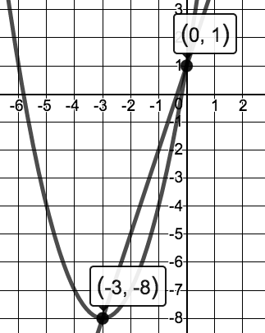  $\left\{\begin{aligned}y=3x+1 \\ y=x^{2}+6x+1\end{aligned}\right.$  are $\boxed{\left(-3, -8\right) \& \left(0, 1\right).}$

Solve each system and verify your solution(s) using the graph.
- $\left\{\begin{aligned}y=x+8 \\ y=-x^{2}-6x-4\end{aligned}\right.$ | 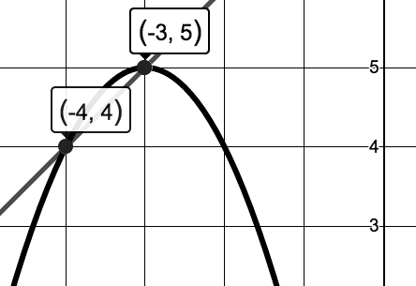 | - $\left\{\begin{aligned}y=5x-4 \\ y=x^{2}-3x+12\end{aligned}\right.$ | 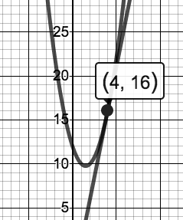
- $\left\{\begin{aligned}y=3x-9 \\ y=x^{2}+2x-6\end{aligned}\right.$ | 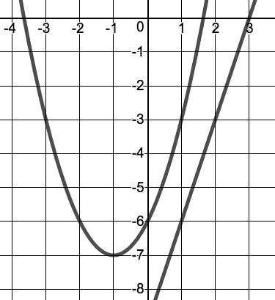  The graphs never cross!  So there will be no real solutions. Stop working when you get the square root of a negative number. That proves that there are no real solutions. | - $\left\{\begin{aligned}y=-2x+6 \\ y=x^{2}+8x+31\end{aligned}\right.$ | 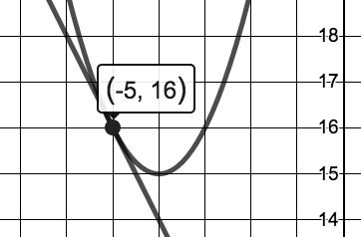
- $\left\{\begin{aligned}y=x+3 \\ y=-3x^{2}+x+2\end{aligned}\right.$ | 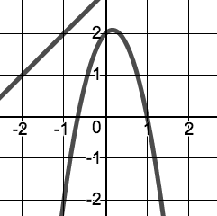 | - $\left\{\begin{aligned}y=-x-4 \\ y=x^{2}+8x+10\end{aligned}\right.$ | 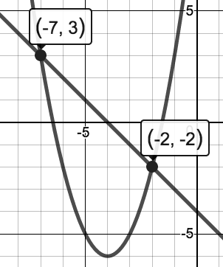
- $\left\{\begin{aligned}y=-x^{2}-6x-2 \\ y=x^{2}+2x+4 \end{aligned}\right.$ | 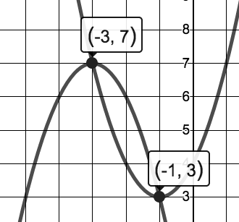 | - $\left\{\begin{aligned}y=-x^{2}+x-3 \\ y=x^{2}-8x+12\end{aligned}\right.$ | 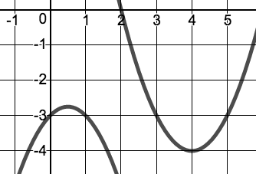
- $\left\{\begin{aligned}y=x^{2}+5x+2 \\ y=x^{2}+3x \end{aligned}\right.$ | 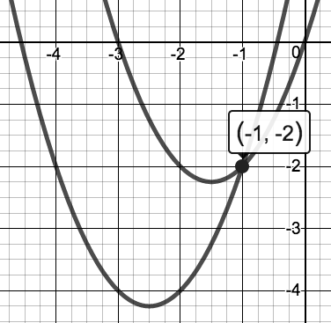 | - $\left\{\begin{aligned}y=x^{2}+5x+9 \\ y=-2x^{2}+5x+12\end{aligned}\right.$ | 