What do you need to study?

Put a *next to any problems you know that you can solve. Circle any problems that you are not certain how to solve. Put a ? next to any problems that you have no idea where to start.

- Simplify. $\left(6x^{5}-2x^{2}\right)-\left(4x^{3}+5x^{2}-9\right)$

- Determine the product. $\left(x-8\right)\left(6x+5\right)$

- Factor completely, then determine the roots of the equation. $x^{2}+6x+8=0$

- Calculate the roots of the quadratic equation, by factoring, if possible. Verify your solution. $3x^{2}+10x+8=0$

- Factor completely. $20x^{2}-45$
- Find the roots of the quadratic function below. $f\left(x\right)=(x+9)(x-4)$

- Determine if the relation below is linear or quadratic.
x | y
1 | 6
2 | -2
3 | -3
4 | 3
5 | 16

- The graph of a quadratic function is shown below. Identify each property listed.
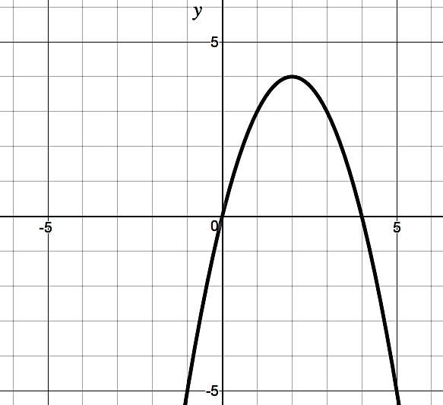
Domain: ____________________ Interval of Increase: ___________________

Interval of Decrease: __________________
Range: ____________________

Zeros: ____________________ x-intercept: ____________________

y-intercept: ____________________

- Find the vertex of $f\left(x\right)=x^{2}+2x-8$. Is it an absolute maximum or minimum? Justify your answer.

- Graph the following quadratic function. $f\left(x\right)={\left(x+2\right)}^{2}-4$

- Graph. $f\left(x\right)=x^{2}-2x-3$

- Find the zeros and write them in interval notation.
$$f(x)<x^{2}-2x-3$$

- As players level up in a video game, the amount of time it takes to earn rewards increases. On the first level, a reward takes 6 minutes. The second level takes 9 minutes, the third level 14 minutes, the fourth level 21 minutes and so on and so forth.
  - Make a table that lists the level and the total minutes it takes.
  - What type of function can model this situation? Explain how you can identify the function type.
  - Write an equation that models the situation.

- Find the value of $r$. ${\left(r+4\right)}^{2}=48$

- Use the quadratic formula to find the zeros. $f\left(x\right)=-2x^{2}+4x-3$

- Solve the system of equations algebraically over the set of real numbers.
$$\left\{\begin{aligned}y=2x-5 \\ y=4x^{2}+10x-17\end{aligned}\right.$$

- Simplify. $i^{47}$

- Simplify. $\sqrt{-64}$

- Simplify. $5+\sqrt{-147}$

- Simplify. $(2+3i)(4-9i)$

- List all words from the box that describe the number, $5+3i$.

Natural Number | Whole Number | Integer | Rational Number | Irrational Number | Real Number | Imaginary Number | Complex Number

- A ball on an unknown planet is tossed upward from a height of 84 feet with an initial vertical velocity of 7 feet per second. Its height can be modeled by the quadratic function $h\left(t\right)=-7x^{2}+7x+84$, where $h\left(t\right)$is the height, in feet, of the ball, and $t$ is the time the ball has been in the air, in seconds.
  - How long will it take for the ball to reach the ground after it has been tossed? Round to the nearest hundredth.
  - Find the maximum height the ball will reach.

- Graph the piecewise function.
$$f(x)=\left\{\begin{aligned}3x+7 \\ -2x-4 \\ 5\end{aligned}\right., \begin{aligned}-5≤x<-1 \\ -1≤x<6 \\ 6<x<9\end{aligned}$$

- Make a table to represent the situation. James works as a clerk. For the first 3 hours of his day, he generated 15 forms each hour. Then, he took an hour for lunch. Upon returning to work, he generated 20 forms each hour for 4 hours before slowing to 10 forms in his last working hour.

- Write a piecewise equation to represent the table.
x | y
0 | 7
1 | 7
2 | 7
3 | 9
4 | 11
5 | 8
6 | 5

- Write the inverse of the table. Is it a one-to-one function?
x | y
-4 | 0
2 | 3
3 | 1
2 | 7
- Write the inverse of the equation. Check to verify that your inverse is correct. $y=\frac{x}{4}-3$

