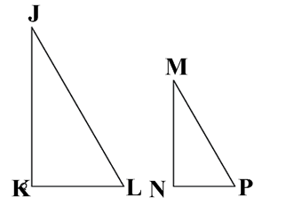  1. Triangle JKL is similar to triangle MNP.  a. Identify and write the corresponding sides and angles of the two triangles. | 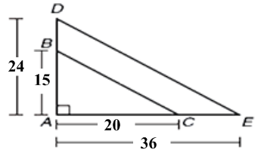  2. Triangles ABC and ADE share angle A and  a. Show your work and determine if triangle ABC is similar to ADE.
3. Carla looks from a height of 6 meters at the top of her apartment building. If the flagpole is 36 meters from the apartment building, how tall is the flagpole? [Hint: draw the two triangles separately and in the same orientation]  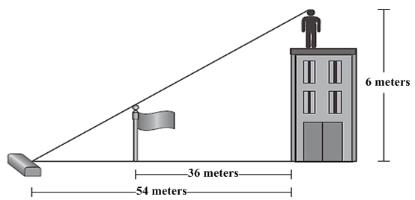 | 4. Victoria holds a 4-foot-long fishing pole. The fishing line extends 7 feet to the water’s surface and then another 11.2 feet to a hook. How far is the fish from the hook?  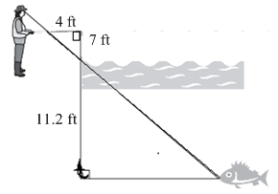
5. Triangle is a dilation of triangle MNO with the center of dilation at the origin.  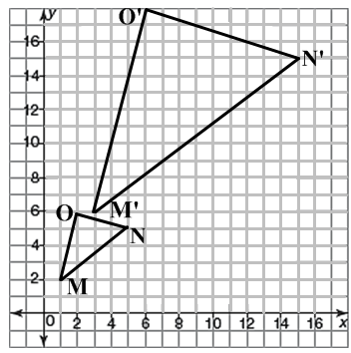  a. What is the scale factor? | 6. Given the two triangles shown.  a. Determine the transformation used to create triangle XYZ.
7. Write the theorems or postulates that show the pair of triangles are congruent.  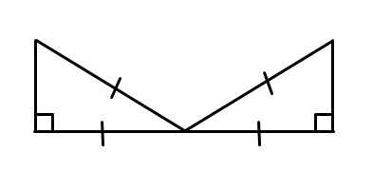 | 9. Use a two-column proof.  Given: $\overline{PS}≅\overline{RQ}$  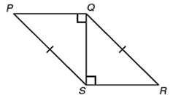  Prove: $∠P≅∠R$  Statements Reasons  1. $∠PQR \& ∠RQS$ are right angles 1. Given  2. ? 2. Given  3. ? 3. Reflexive Prop. $≅$  4. $△PQS≅△RSQ$ 4. ?  5. $∠P≅∠R$ 5. ?
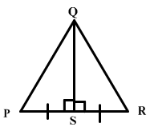
8. In the figure shown, $\overline{PS}≅\overline{RS}$. Which theorem can be used to prove $△PQS≅△RQS$?

Answers to Unit 6 Practice Test
1. $∠J \& ∠M, ∠K \& ∠N, ∠L \& ∠P$,  $$\overline{JK}≅\overline{MN}, \overline{KL}≅\overline{NP}, \overline{JL}≅\overline{MP}$$ | 2. $\frac{15}{21}=\frac{5}{7} \& \frac{20}{36}=\frac{5}{9}$ not equal fractions, so not similar
3. 2 meters | 4. 6.4 ft
5. 3 | 6. Rotation
7. HL | 9-2. $\overline{PS}≅\overline{RQ}$  9-3. $\overline{QS}≅\overline{SQ}$ or $\overline{QS}≅\overline{QS}$  9-4. HL  9-5. CPCTC
8. SAS

Answers to Unit 6 Practice Test
1. $∠J \& ∠M, ∠K \& ∠N, ∠L \& ∠P$,  $$\overline{JK}≅\overline{MN}, \overline{KL}≅\overline{NP}, \overline{JL}≅\overline{MP}$$ | 2. $\frac{15}{21}=\frac{5}{7} \& \frac{20}{36}=\frac{5}{9}$ not equal fractions, so not similar
3. 2 meters | 4. 6.4 ft
5. 3 | 6. Rotation
7. HL | 9-2. $\overline{PS}≅\overline{RQ}$  9-3. $\overline{QS}≅\overline{SQ}$ or $\overline{QS}≅\overline{QS}$  9-4. HL  9-5. CPCTC
8. SAS

Answers to Unit 6 Practice Test
1. $∠J \& ∠M, ∠K \& ∠N, ∠L \& ∠P$,  $$\overline{JK}≅\overline{MN}, \overline{KL}≅\overline{NP}, \overline{JL}≅\overline{MP}$$ | 2. $\frac{15}{21}=\frac{5}{7} \& \frac{20}{36}=\frac{5}{9}$ not equal fractions, so not similar
3. 2 meters | 4. 6.4 ft
5. 3 | 6. Rotation
7. HL | 9-2. $\overline{PS}≅\overline{RQ}$  9-3. $\overline{QS}≅\overline{SQ}$ or $\overline{QS}≅\overline{QS}$  9-4. HL  9-5. CPCTC
8. SAS

Answers to Unit 6 Practice Test
1. $∠J \& ∠M, ∠K \& ∠N, ∠L \& ∠P$,  $$\overline{JK}≅\overline{MN}, \overline{KL}≅\overline{NP}, \overline{JL}≅\overline{MP}$$ | 2. $\frac{15}{21}=\frac{5}{7} \& \frac{20}{36}=\frac{5}{9}$ not equal fractions, so not similar
3. 2 meters | 4. 6.4 ft
5. 3 | 6. Rotation
7. HL | 9-2. $\overline{PS}≅\overline{RQ}$  9-3. $\overline{QS}≅\overline{SQ}$ or $\overline{QS}≅\overline{QS}$  9-4. HL  9-5. CPCTC
8. SAS

Answers to Unit 6 Practice Test
1. $∠J \& ∠M, ∠K \& ∠N, ∠L \& ∠P$,  $$\overline{JK}≅\overline{MN}, \overline{KL}≅\overline{NP}, \overline{JL}≅\overline{MP}$$ | 2. $\frac{15}{21}=\frac{5}{7} \& \frac{20}{36}=\frac{5}{9}$ not equal fractions, so not similar
3. 2 meters | 4. 6.4 ft
5. 3 | 6. Rotation
7. HL | 9-2. $\overline{PS}≅\overline{RQ}$  9-3. $\overline{QS}≅\overline{SQ}$ or $\overline{QS}≅\overline{QS}$  9-4. HL  9-5. CPCTC
8. SAS

